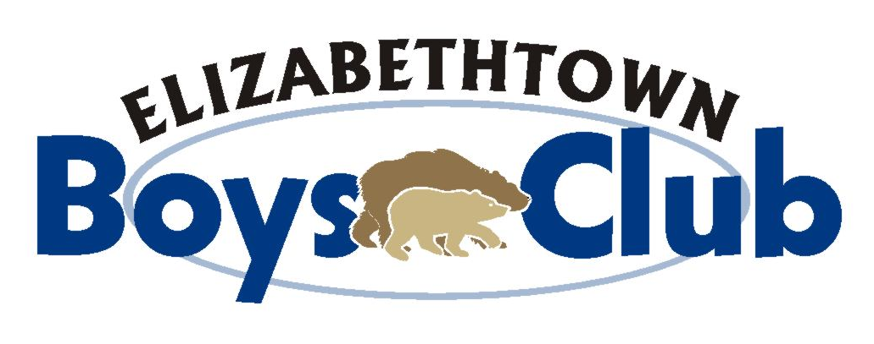

EBC YOUTH Baseball

2017 Baseball Season registration
Player age dates are changing in 2017 for all ages
(11-under)so that we are in line with Little League’s new age change.
There will be a complete re-draft of all players due to age date changes

**** UNIFORMS ARE PROVIDED ****

5 Divisions:

JR. MIDGET: Ages 13 - 14 (by 4/30/17)
M-MIDGET: Ages 12 (by 4/30/17)
M-MIDGET: Ages 11 (by 8/31/17)
PONY: Ages 9 - 10 (by 8/31/17)
COLT: Ages 7 - 8 (by 8/31/17)
(Players will pitch to batters from 40 ft.)
T-Ball: Ages 5 – 6 (by 8/31/17))

Registration at GEARS Community Center -- Poplar Street, Etown

Sat. Jan. 7, 2017 9:00am – 12:00pm Registration Fee:
Sat. Jan. 14, 2017 9:00am – 12:00pm Jr. Midget………$55.00*
Sat. Jan. 21, 2017 9:00am – 12:00 pm M-Midget, Pony, Colt…$35.00
Sat. Jan. 28, 2017 9:00am – 12:00 pm T-Ball…. $25.00*
Sat. Feb. 4, 2017 9:00am – 12:00 pm To Opt-Out of the sub sale will
Sat. Feb. 11, 2017 9:00am – 12:00 pm cost an additional $30.00
*No Multi-Player Discount
On-Line Registration starting January 1, 2017
Website: www.etownboysclub.com – Click on “Registration”
First time players must provide a copy of birth certificate
IMPORTANT: Any player, who signs up after 2/13/17, will have to pay late fee of $15.00
M-Midget, Pony & Colt Evaluations: 2/25/2017 and 3/4/2017
Jr-Midget Evaluations : 2/27/2017 – 3/2/2017

Opening Day is scheduled for April 8th@ Wenger Field!
M-Midget, Pony & Colt regular seasons will start the week of April 3rd
Playoffs: Colts: June 3th thru June 9th, 2016 / Pony: June 10 th thru 16th, 2016 / M-Midget: June 17th thru 23rd, 2017

For any questions, contact: Jeremy Wolfe (Commissioner) at: ebc.bb.commissioner@gmail.com or 717-824-9677
Mailing Address for Signups: Elizabethtown Boys Club Make checks payable to: EBC
Attn: Baseball Signups
103 Crimson Lane, Elizabethtown, PA 17022

Disclaimer: This activity is neither sponsored nor endorsed by the Elizabethtown Area Board of School Directors, the Superintendent or Elizabethtown Area School District.

